[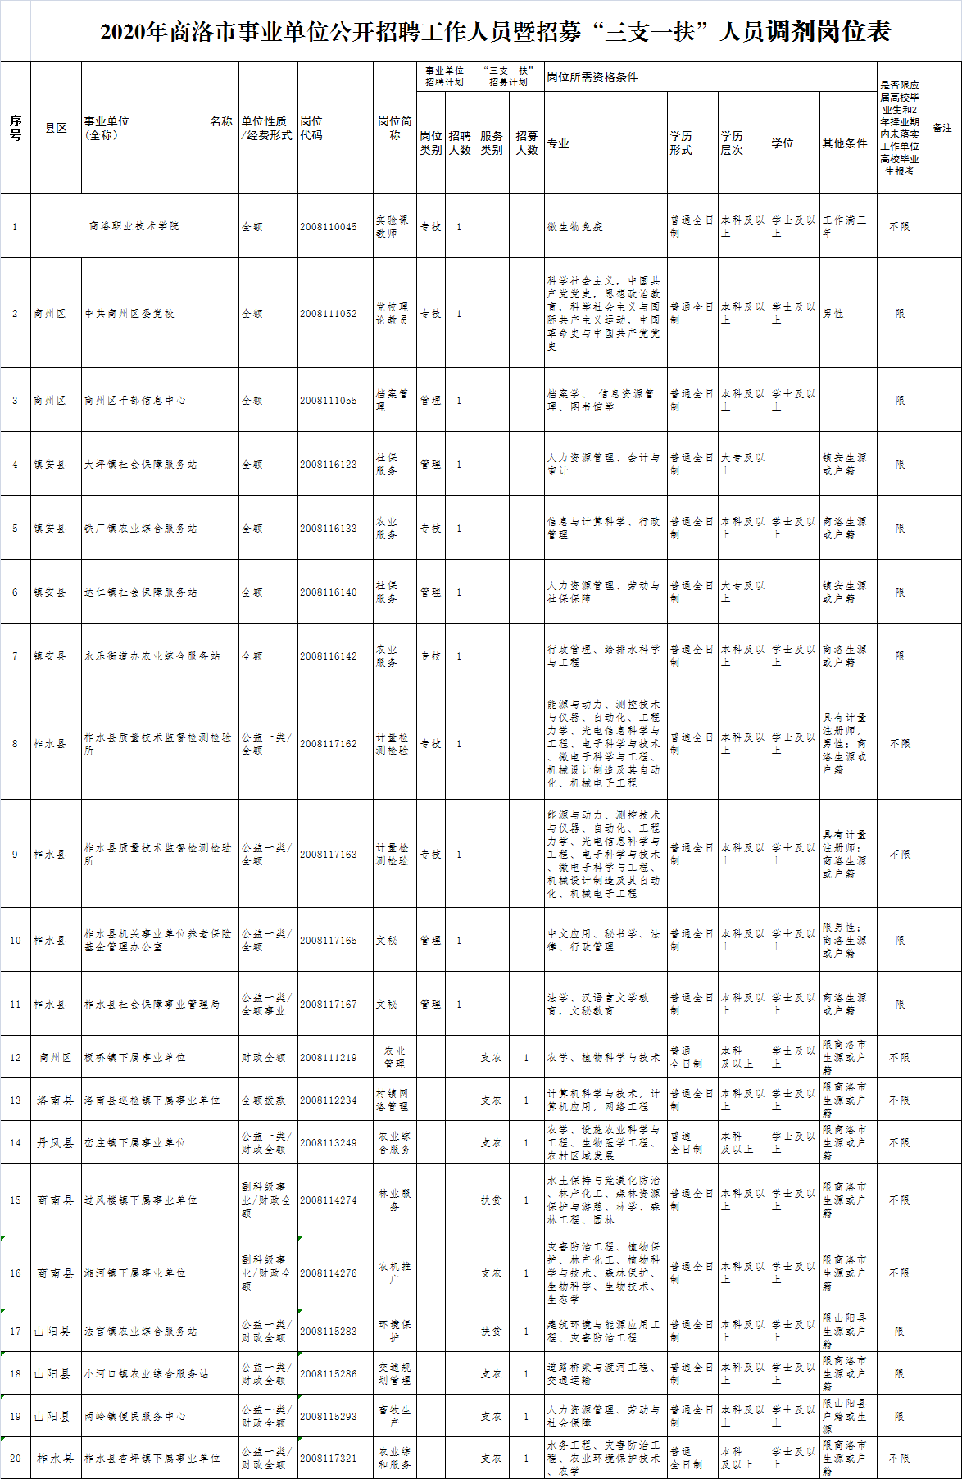](http://rsj.shangluo.gov.cn/upfiles/image/20201016/2020101618460129129.png)