[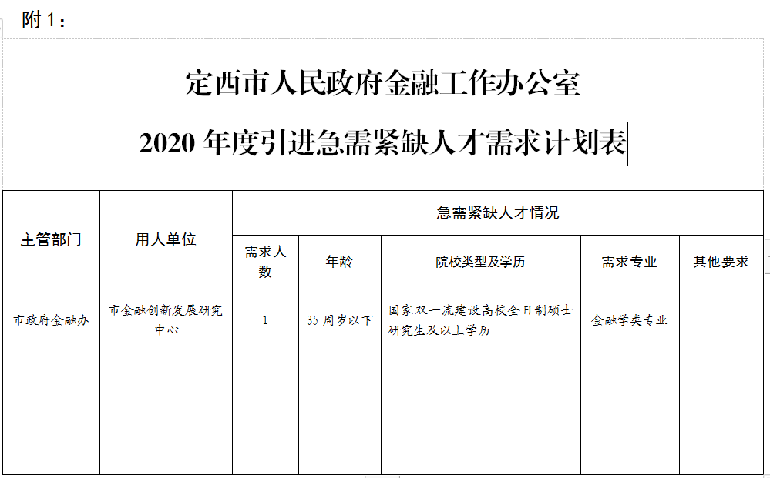](http://zwgk.dingxi.gov.cn/picture/0/2006131131108041773.png)